Horse Farms Forever
Conservation Summit Summary
August 2, 2021

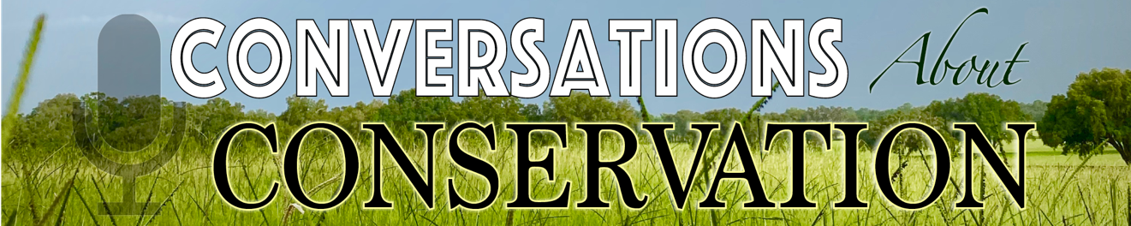

Preserving Our Farmland. Upholding Our Brand. Let’s Talk, Marion County.

Announcing the 2021 Conservation Summit, presented by Brook Ledge Horse Transportation

Horse Farms Forever will hold its Second Annual Conservation Summit: Conversations about Conservation on November 23, 2021, at the Ocala Breeders’ Sales Arena from 12:00 PM to 1:30 PM. Lunch will be served from 11:00 AM to 12:00 PM. The event will also be webcast.

The Conservation Summit is a premier educational workshop about how to balance growth with preserving Marion County's 193,000-acre Farmland Preservation Area. The purpose of the Summit is to inspire the preservation of the horse farms and agricultural lands that are fundamental to Marion County’s global brand as the Horse Capital of the World®.

Cable Cowboy
Gracing the stage as the Keynote Speaker of the Summit will be Liberty Media Chairman and businessman extraordinaire, Mr. John C. Malone. Nicknamed the “cable cowboy”, he is a larger-than-life business executive, philanthropist, and conversationalist. With over 2.2 million acres to his name including Ocala’s historic Bridlewood Farm, Malone is the largest private landowner in North America. Mr. Malone is sure to delight the audience with his remarkable story and profound passion for land conservation.
Growing With an Eye on Preservation
Kevin Sheilley, President and CEO of the Ocala Metro Chamber and Economic Partnership (Ocala CEP) will be the featured Guest Speaker. Mr. Sheilley is a well-respected leader in innovative regional development and was instrumental in the Ocala CEP’s recognition as the 2020 National Chamber of the Year. He will shine a light on the exciting economic and business development happenings in Marion County while also speaking to the importance of balancing growth.

Mr. Sheilley will also present the results of the county-wide Quality-of-Life Survey conducted by The Matrix Group this summer.

Survey Says…
The Quality-of-Life Survey is a collaborative effort to understand the needs and desires of Marion County’s residents. It is organized by Horse Farms Forever and is sponsored by the Ocala Metro Chamber and Economic Partnership, College of Central Florida, Ocala Horse Properties, the Florida Thoroughbred Breeders’ and Owners’ Association and Hotel Design and Management Group.

This survey is an important step in defining the issues facing Marion County. Over the next 20 years, Marion County’s population is projected to grow by about 150,000 new residents. By taking a step back to assess our strengths and weaknesses, this survey is an opportunity to work together to strengthen our community and economy.

Who Will Win the Acorn?
Horse Farms Forever will also be honoring one of Marion County’s most prominent landowners with an inaugural Acorn Conservation Award.

Join the Conversation
Be a part of this important conversation which is all the more relevant as Marion County experiences unprecedented growth. Tickets can be purchased for in-person or virtual attendance at https://www.horsefarmsforever.com/conservation-summit/. In-person registration will remain open until November 9, 2021. Virtual registration will remain open until November 22.

The Event hashtag is #ConversationsaboutConservation2021

To learn more about sponsorship and vendor opportunities, please contact Horse Farms Forever’s Executive Director, Sara Fennessy, at sara.fennessy@horsefarmsforever.com

Learn More About:

Keynote Speaker John Malone
https://www.horsefarmsforever.com/john-malone/

Guest Speaker Kevin Sheilley
https://www.horsefarmsforever.com/kevin-sheilley/

The Matrix Group – Quality-of-Life Survey Research Firm
https://www.tmgresearch.com

2020 Conservation Summit:
https://www.horsefarmsforever.com/conservation-summit-2020/

