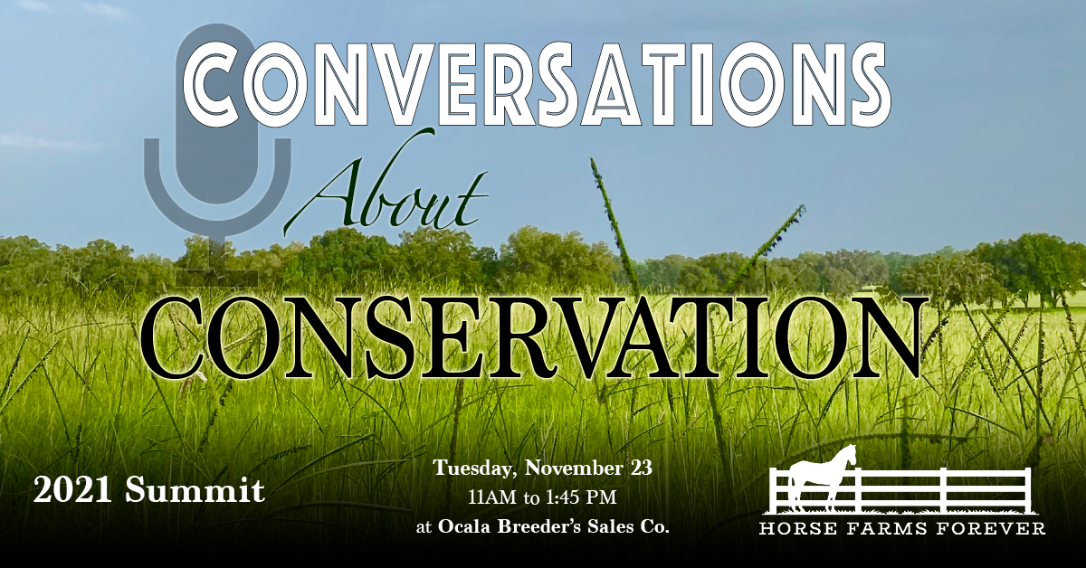

We’ve Joined the Conversation

[Enter Company Name] is proud to be sponsoring Horse Farms Forever’s 2021 Summit – Conversations About Conservation, to be held on November 23 at Ocala Breeder’s Sales Company.

Marion County’s open spaces and horse farms are the defining factor in its unique identity. We want to be part of solutions that support healthy growth without losing our global brand as Horse Capital of the World®.
Join us at Ocala Breeder's Sales Co. for lunch and hear from keynote speaker, John Malone – conservationist, owner of Bridlewood Farm, and the largest private landowner in the U.S. Also hear the results of the extensive Marion County Quality of Life Survey and a report by Kevin Sheilley of the Ocala Metro CEP, on how Ocala/Marion County can grow gracefully in the midst of its economic boom. Horse Farms Forever will also debut its annual Acorn Conservation Award at the Summit. It will be awarded to a Marion County landowner who has shown a steadfast commitment to preserving Ocala/Marion County’s open spaces and beautiful places.

This Event will be live-streamed as well, for anyone who would like to attend virtually.

Ocala/Marion County is getting serious about conservation. We invite you to join the conversation.

The Summit begins at 11am with lunch in OBS’ newly-renovated dining area. The educational program starts at 12 noon in the sales auditorium and concludes at 1:30 pm. Summit sponsors will have exhibits in the foyer to greet and further inform you during the lunch hour.

Registration is online. The deadline for in-person attendance is November 9. You can sign up for virtual attendance up until November 22.

We hope to see you at OBS on November 23!

The main information page for the Summit is: https://www.horsefarmsforever.com/conservation-summit/ and the event hashtag is #ConversationsaboutConservation2021.

