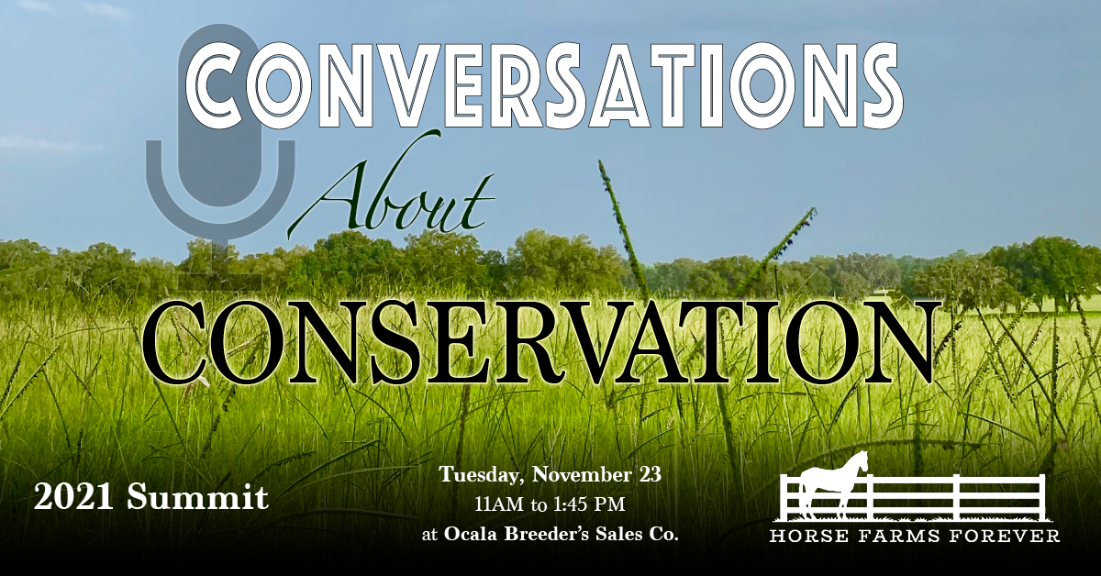

The event hashtag is #ConversationsaboutConservation2021
Our Twitter handle is @HorseFarms4Ever
On Facebook and Instagram, we are @Horse Farms Forever
The event website is https://www.horsefarmsforever.com/conservation-summit/

Sample Tweets
We’re sponsoring #ConversationsaboutConservation2021, @HorseFarms4Ever Summit on November 23. Join us! https://www.horsefarmsforever.com/conservation-summit/
Hear the Cable Cowboy, John Malone, at #obssales on November 23. #ConversationsaboutConservation2021 https://www.horsefarmsforever.com/conservation-summit/
Who cares about quality-of-life in Marion County? Results of the county-wide survey to be announced at #ConversationsaboutConservation2021 https://www.horsefarmsforever.com/conservation-summit/
What will it take to keep Ocala open and beautiful? #ConversationsaboutConservation2021 join the conversation https://www.horsefarmsforever.com/conservation-summit/

FACEBOOK/INSTAGRAM

[Enter Company Name] is proud to be sponsoring Horse Farms Forever’s 2021 Summit – Conversations About Conservation, to be held on November 23 at Ocala Breeder’s Sales Company.
Join us at Ocala Breeder's Sales Co. for lunch and hear from keynote speaker, John Malone – conservationist, owner of Bridlewood Farm, and the largest private landowner in the U.S. Also hear the results of the extensive Marion County Quality of Life Survey and a report by Kevin Sheilley of the Ocala Metro CEP, on how Ocala/Marion County can grow gracefully in the midst of its economic boom. Horse Farms Forever will also debut its annual Acorn Conservation Award at the Summit. It will be awarded to a Marion County landowner who has shown a steadfast commitment to preserving Ocala/Marion County’s open spaces and beautiful places.

This Event will be live-streamed as well, for anyone who would like to attend virtually.

Ocala/Marion County is getting serious about conservation. We invite you to join the conversation.

Registration is online. The deadline for in-person attendance is November 9. You can sign up for virtual attendance up until November 22. ______________________________________________________________________________________

Marion County’s open spaces and horse farms are the defining factor in its unique identity. We want to be part of solutions that support healthy growth without losing our global brand as Horse Capital of the World®. Join us at Horse Farms Forever’s 2021 Summit – Conversations About Conservation, to be held on November 23 at Ocala Breeder’s Sales Company. Registration is online. The deadline for in-person attendance is November 9. You can sign up for virtual attendance up until November 22.
Ocala/Marion County is getting serious about conservation. We invite you to join the conversation. Proud to be sponsoring #ConversationsaboutConservations2021 on November 23 at Ocala Breeder’s Sales. Register online to attend in-person or view the webcast.

John Malone is the largest private landowner in North America and chairman of Liberty Media. He’s also the owner of Bridlewood Farm. Come and hear him speak about his passion for land conservation at Horse Farms Forever’s 2021 Summit – Conversations About Conservation on November 23 at Ocala Breeder’s Sales Company. Register online before November 9.
#ConversationsaboutConservation2021

Who cares about quality-of-life in Marion County? We do. And so do a lot of other people. Want to find out what they care about? Horse Farms Forever teamed up with the business and academic community to conduct a professionally-curated survey of Marion County. Results will be announced at their annual Conservation Summit: #ConversationsaboutConservation2021 https://www.horsefarmsforever.com/conservation-summit/. Join us there! Register online before November 9.

